Elman Networks

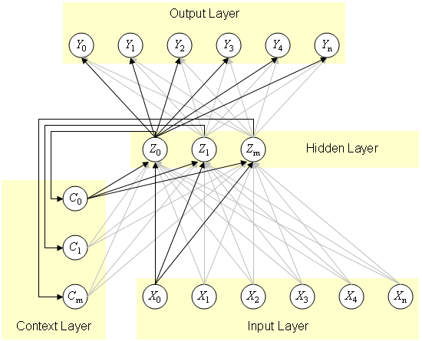
Figure 1. A common structure of an Elman network. Note the context layer, which receives input from, and returns values to, the hidden layer.

In Figure 1 is an example of a simple recurrent network design with potential to learn an unlimited number of sequences of varying length. Elman and others intended the input and output units to represent individual letters, with which the network could be trained to predict the next letter in a string of letters.
However, the nature of this kind of recurrent network is easier to understand, simply by referring to the unit's position in serial order (i.e.; Y₀, Y₁, Y₂, Y₃, ...). So for the purpose of this illustration, I'll just use strings of numbers like: 0, 3, 5, 2, 0, where 0 refers to Y₀, 3 refers to Y₃, 5 refers to Y₅, etc. Each string begins and ends with a terminal symbol; I'll use 0 for this example.
Other than beginning and ending with the terminal symbol, the order of the numbers within the string can be any order. And with enough units in the network, the length of string is without limit.
The neural net architecture for this example has six input, and six output units (for numbers 1 through 5, plus 0 for the terminal symbol). There are three hidden units, with three corresponding context units.
Since X₀ represents the terminal symbol, its input is 1, all other inputs are 0. The terminal symbol would correspond to the vector (1, 0, 0, 0, 0, 0). The rest would follow this pattern:
1 = 0, 1, 0, 0, 0, 0
2 = 0, 0, 1, 0, 0, 0
3 = 0, 0, 0, 1, 0, 0
4 = 0, 0, 0, 0, 1, 0
5 = 0, 0, 0, 0, 0, 1
Training the net for a particular string involves several steps, the number depending on the length of the string. The context units receive a copy of the hidden unit's activations, and the next symbol in the training string (which was the target for the output units on the first step of training) is presented to the input units. Training continues in this manner until another instance of the terminal symbol (0) is reached.

